Mohsin Iban Hossain
AIUB, Engineering Management Notes
ENGINEERING MANAGEMENT
Table of Contents
Sl. No | Topic | Pages
1 | Fundamentals Of Management | 03-15
2 | Competitiveness, and Productivity | 16-32
3 | Forecasting | 33-51
4 | Strategic Capacity Planning for Products and Services | 52-75

FUNDAMENTALS OF MANAGEMENT
What is Management?
- Management means getting things done through people — by using available resources wisely and effectively to achieve goals.

- Definition of Management:
Mary Parker Follett (1919):
“Management is the art of getting things done with and through people.”
Chester I. Barnard:
“Management is getting things done through people by making efficient use of resources.”
Henri Fayol (1949):
“To manage is to forecast, to plan, to organize, to command, to coordinate, and to control.”
Peter Drucker (1954):
“Management is doing things right; leadership is doing the right things.”
Ricky W. Griffin (2012):
“Management is a set of activities (Planning, Organizing, Leading, and Controlling) directed at an organization’s resources (human, financial, physical, and information) to achieve goals effectively and efficiently in a changing environment.”
- In Simple Terms: Management means deciding what to do, how to do it, who will do it, and checking if it’s done properly — all to make sure goals are met with minimum waste and maximum results.
Purpose of Management
- The main purpose of management is to help an organization achieve its goals efficiently and effectively using available resources.

- Efficiency: Doing things in the best possible way with minimum waste of time, money, and effort.

Example: Producing 100 quality products using fewer materials or less time.

- Effectiveness: Choosing the right goals and making sure they are successfully achieved.
Example: Launching the product that customers actually want and getting good sales.
- In Simple Terms:
  - Efficiency means doing things right.
  - Effectiveness means doing the right things.

Example:
Suppose a manager leads a team to make eco-friendly bags.
- If they make the bags using minimal cost and materials, that’s efficiency.
- If they sell the bags successfully to eco-conscious customers, that’s effectiveness.
Goals and Objectives of Management
- Management always works toward achieving results — these are called goals and objectives. Although the two words sound similar, they have slightly different meanings.

  - Goal: A goal is a broad, general statement about what an organization or individual wants to achieve.

Example: “Become the leading brand in the market.” Or “Provide quality education to students.”

  - Objective: An objective is a specific and measurable target that helps achieve the larger goal.
Example: “Increase sales by 20% within the next 6 months.” Or “Open 3 new branches this year.”

- In Simple Terms:
  - A goal shows the direction — it tells where we want to go, not how to get there.*
  - Objectives are steps or milestones to reach the main goal.
Difference Between Goal and Objective
Feature | Goal | Objective
Nature | Broad and general | Specific and measurable
Focus | Long-term direction | Short-term achievement
Example | Improve customer satisfaction | Get 90% positive reviews this quarter

Types of Objectives
- Management sets objectives at different levels of the organization:
- Organizational Objectives – Overall targets for the whole company.
Example: Increase total profit by 10%.
- Departmental Objectives – Goals for each department.
Example: The sales department aims to reach 5,000 new customers.
- Subunit Objectives – Goals for smaller sections within departments.
Example: The online sales team targets 2,000 new customers.
- Individual Objectives – Personal goals for employees.
Example: A salesperson aims to sell 200 products this month.
Who Are Managers?
- Managers are the people who plan, organize, lead, and control the work of others to achieve the goals of an organization. Or

- A manager is someone whose main job is to carry out the management process — making sure that the organization runs smoothly and efficiently.
Key Responsibilities of Managers
- Planning: Deciding what needs to be done and setting goals for the team or organization.
- Organizing: Arranging people, tasks, and resources in the right way to meet the plan.
- Leading: Motivating and guiding employees to work hard and stay committed.
- Controlling: Checking progress, comparing results with goals, and fixing problems.
Resources Managed by Managers
- Managers are responsible for handling different types of resources in an organization:
- Human Resources: People or employees.
- Financial Resources: Money and budgets.
- Physical Resources: Buildings, machines, tools, etc.
- Information Resources: Data and knowledge used for decision-making.

Example:
A restaurant manager:
- Plans the menu (Planning)
- Assigns chefs and waiters (Organizing)
- Motivates staff and resolves issues (Leading)
- Checks customer satisfaction and sales reports (Controlling)
Levels of Management
- In every organization, management is divided into three main levels.
Each level has different responsibilities, but all work together to achieve the same goals.
1. Top-Level Management
- Who They Are:
  - Chief Executive Officer (CEO)
  - Managing Director (MD)
  - Board of Directors
  - General Managers
- Main Roles:
  - Set the overall goals and direction of the organization.
  - Make long-term plans and major decisions.
  - Develop company policies and strategies.
  - Represent the organization to the outside world (government, media, investors).
Example: A CEO decides to expand the company into new international markets.
2. Middle-Level Management
- Who They Are:
  - Department Heads
  - Branch Managers
  - Division Managers
  - Project Leaders

- Main Roles:
  - Implement the policies and plans made by top management.
  - Supervise and coordinate activities of lower-level managers.
  - Act as a bridge between top and first-line managers.
  - Focus on achieving departmental goals.
Example: A marketing manager plans an advertising campaign to increase product sales.
3. First-Line (Lower-Level) Management
- Who They Are:
  - Supervisors
  - Team Leaders
  - Foremen
  - Office Managers
- Main Roles:
  - Directly oversee the employees who perform the day-to-day work.
  - Ensure tasks are done efficiently and correctly.
  - Handle minor problems and report results to higher management.
  - Motivate workers and maintain discipline.
Example: A shift supervisor in a factory ensures that workers meet daily production targets.

Kinds of Managers by Area
- Managers can also be classified based on the specific area or department they work in.
Each type of manager focuses on a particular part of the organization’s operations.
1. Marketing Managers
- Role:
- Work in areas related to promoting and selling products or services.
- Responsibilities:
  - Develop new products
  - Plan advertising and promotions
  - Manage pricing and distribution
  - Study customer needs and market trends
Example: A marketing manager runs a social media campaign to attract new customers.
2. Financial Managers
- Role:
- Handle all financial resources of the organization.
- Responsibilities:
  - Prepare budgets and manage cash flow
  - Supervise accounting and financial reporting
  - Make investment decisions
  - Ensure proper use of funds
Example: A financial manager plans how to reduce company expenses while increasing profits.

3. Operations Managers
- Role:
- Oversee the production and delivery of goods or services.
- Responsibilities:
  - Manage production schedules
  - Maintain quality control
  - Supervise inventory and logistics
  - Select plant location and layout
Example: An operations manager ensures products are manufactured on time and meet quality standards.

4. Human Resource (HR) Managers
- Role:
- Focus on managing people within the organization.
- Responsibilities:
  - Hire, train, and develop employees
  - Handle employee relations and performance appraisals
  - Manage salaries, benefits, and policies
  - Ensure employee satisfaction and compliance with labor laws
Example: An HR manager conducts interviews and trains new employees.

5. Administrative Managers
- Role:
- Act as generalists who are familiar with all functional areas of management.
- Responsibilities:
  - Coordinate between different departments
  - Manage office operations
  - Support top management in decision-making
Example: An administrative manager ensures smooth coordination between the HR, finance, and marketing departments.
6. Other Specialized Managers
- Role:
- Focus on specific areas based on organizational needs.
- Responsibilities:
  - Prepare budgets and manage cash flow
  - Supervise accounting and financial reporting
  - Make investment decisions
  - Ensure proper use of funds

Example:
- Public Relations (PR) Manager: Manages the company’s image and communication with the public.
- IT Manager: Oversees computer systems and digital operations.
- R&D Manager: Leads research and product innovation.

Managerial Roles (Mintzberg’s Roles)
- Famous management researcher Henry Mintzberg identified 10 key roles that managers perform in their daily work. These roles are grouped into three main categories — Interpersonal, Informational, and Decisional.
1. Interpersonal Roles
- These roles involve interacting with people inside and outside the organization.
Role | Description | Example
Figurehead | Represents the organization in formal events and ceremonies. | Attending a company anniversary event.
Leader | Motivates and guides employees to achieve goals. | Encouraging the sales team to reach targets.
Liaison | Builds and maintains relationships with external contacts. | Meeting clients or business partners.

2. Informational Roles
- Managers need to collect and share information to keep everyone updated.
Role | Simple Meaning | Example
Monitor | Finds out what’s happening inside and outside the company. | Reading reports or checking feedback.
Disseminator | Shares important information with team members. | Sending updates or instructions to employees.
Spokesperson | Speaks for the company to others. | Giving a presentation or interview.

3. Decisional Roles
- Managers must solve problems and make choices that help the company grow.
Role | Simple Meaning | Example
Entrepreneur | Thinks of new ideas and improvements. | Starting a new project.
Disturbance Handler | Fixes problems and handles emergencies. | Solving a customer complaint.
Resource Allocator | Decides how to use money, people, and time. | Setting budgets or assigning tasks.
Negotiator | Makes deals and agreements with others. | Discussing a contract with suppliers.
Managerial Roles (Mintzberg’s Roles)
- To be a good manager, a person needs to have some important skills. These skills help them plan work, guide people, and solve problems.
Skill | Meaning | Example
Technical | Knowing how to do the job | Coding, machine operation
Human | Working well with others | Motivating employees
Conceptual | Thinking big and planning | Making strategies
Diagnostic | Finding and fixing issues | Solving sales problems
Communication | Sharing ideas clearly | Giving presentations
Decision-Making | Choosing the best option | Selecting a new project
Time-Management | Using time efficiently | Finishing work on schedule

Skill Requirements at Different Levels of Management
- Managers at different levels (top, middle, and first-line) need different types of skills because their jobs are not the same.
1. Top-Level Managers
- Who They Are:
  - CEO, Managing Director, Chairman, or General Manager.
- What They Do:
  - Make long-term plans and goals.
  - Think about the future of the company.
  - Make big decisions for the whole organization.
- Skills They Need Most:
  - Conceptual Skill: To understand the big picture and plan strategies.
  - Decision-Making Skill: To make strong and smart choices.
  - Human Skill: To lead and inspire others.
2. Middle-Level Managers
- Who They Are:
  - Department heads, branch managers, project leaders.
- What They Do:
  - Connect top managers with lower managers.
  - Implement plans made by top-level managers.
  - Supervise the work of first-line managers.
- Skills They Need Most:
  - A balance of all skills —Technical, Human, and Conceptual skills.

3. First-Line (Lower-Level) Managers
- Who They Are:
  - Supervisors, team leaders, or foremen.
- What They Do:
  - Directly manage workers doing the actual job.
  - Check daily performance and solve small problems.
  - Report progress to middle management.
- Skills They Need Most:
  - Technical Skill: To understand the actual work.
  - Human Skill: To guide and motivate workers.
Summary Table
Level | Main Skills Needed | Example
Top-Level | Conceptual, Decision-Making, Human | CEO planning company goals
Middle-Level | Technical, Human, Conceptual (balanced) | Department manager managing teams
First-Line | Technical, Human | Supervisor guiding workers

Competitiveness, and Productivity

Productivity
- Productivity is an index that measures output (goods and services) relative to the input (labor, material, energy, capital, etc.) used to produce them.
In simple terms, it shows how efficiently resources are utilized to generate output.
$$Productivity=\frac{Output}{Input }​$$

Why Productivity Matters
• For non-profit organizations, higher productivity means lower costs and better resource utilization.
• For profit-oriented organizations, productivity determines competitiveness, profitability, and sustainability.
• For a nation, productivity growth improves the standard of living, economic development, and global competitiveness.
Types of Productivity Measures
A. Partial Productivity:
- Based on a single input (e.g., labor, material, or energy).
- Measures the efficiency of one resource only.
$$Partial Productivity=\frac{Output}{Single Input }$$

Note: For Single factor productivity / partial measure productivity input = 1

B. Multifactor Productivity (MFP):
- Based on multiple inputs such as labor, materials, and capital.
- Provides a more comprehensive efficiency measure.
$$MFP=\frac{Output}{Sum of Multiple Input }$$
Note: For Multifactor productivity / multi measure productivity input > 1
C. Total Productivity:
- Considers all inputs and all outputs together.
- Represents overall efficiency of an organization or process.
$$Total Productivity=\frac{Total Output}{Total Input }$$

- Problem1: Two manufacturing companies, Company A and Company B, produce similar plastic components. To evaluate their performance, the management wants to compare how effectively each company utilizes its key resources — labor, material, and energy — in daily production.
Company | Output (pieces/day) | Labor (persons) | Material (kg/day) | Energy (kWh/day)
A | 1000 | 10 | 200 | 100
B | 2000 | 20 | 500 | 150
The following data represent the daily production record of both companies:

a) Determine the labor productivity of each company in terms of pieces per labor per day.
b) Determine the material productivity of each company in terms of pieces per kilogram of material used.
c) Determine the energy productivity of each company in terms of pieces per kilowatt-hour of energy consumed.
(a)
C-A C-B
Is given,
Labor = 20
Output = 2000 pics/day
We know,
$$labor productivity= \frac{output}{input}$$
$$labor productivity= \frac{2000 pics/day}{20 labor}$$
= 100 pics/day/labor

Is given,
Labor = 10
Output = 1000 pics/day
We know,
$$labor productivity= \frac{output}{input}$$
$$labor productivity= \frac{1000 pics/day}{10 labor}$$
= 100 pics/day/labor

(b)
C-A C-B
Is given,
Material = 500 kg/day
Output = 2000 pics/day
We know,
$$Material productivity= \frac{output}{input}$$
$$Material productivity= \frac{2000 pics/day}{500 kg/day}$$
= 2 pics/kg

Is given,
Material = 200 kg/day
Output = 1000 pics/day
We know,
$$Material productivity= \frac{output}{input}$$
$$Material productivity= \frac{1000 pics/day}{200 kg/day}$$
= 5 pics/kg
(c)
C-A C-B
Is given,
Energy = 150 kwh/day
Output = 1000 pics/day
We know,
$$Energy productivity= \frac{output}{input}$$
$$Energy productivity= \frac{2000 pics/day}{150 kwh/day}$$
$≈$13 pics/kwh

Is given,
Energy = 100 kwh/day
Output = 1000 pics/day
We know,
$$Energy productivity= \frac{output}{input}$$
$$Energy productivity= \frac{1000 pics/day}{100 kwh/day}$$
= 10 pics/kwh

- Problem2: A company manufactures smart watches. Each shift has 20 workers, and the company runs 2 shifts. Each shift is 8 hours long. The company operates 5 days per week for 48 weeks in a year. The wage rate is $10 per hour.
For the year 2022 the company reports:
- Material cost: $30,000
- Energy cost: $10,000
- Overhead: 20% of total labor cost
- Total units produced: 1,000 smart watches
- Quality rejection rate: 5% of produced units (these are not approved for sale)
- Average selling price: $100 per smart watch
Management asks:
- What was the multifactor productivity in 2022 expressed as revenue generated per dollar of input?
- In 2023 the company plans a one-time investment of $2,000 that will raise the quality approval rate to 100% while production quantity stays the same as 2022. As the operations manager, will this investment improve multifactor productivity? Show reasoning
Solution:
Is given,
- Workers per shift = 20, number of shifts = 2 → total workers = 20 × 2 = 40.
- Hours per worker per year = 8 hours/day × 5 days/week × 48 weeks = 1,920 hours.
- Labor wage = $10/hr → annual labor cost per worker = 1,920 × $10 = $19,200.
- Total labor cost = 40 workers × $19,200 = $768,000.
- Overhead = 20% of labor cost = 0.20 × $768,000 = $153,600.
- Material cost = $30,000.
- Energy cost = $10,000.
- Produced = 1,000 units; rejection = 5% → Actually Sells = 95% of 1,000 = 950 units.
- Selling price = $100
(a)
We know,
∴ Total input cost (2022) = labor + overhead + material + energy
= $768,000 + $153,600 + $30,000 + $10,000
= $961,600
∴ Revenue (2022) = Actually Sells $×$ Selling price
= 950 $× 100$
= $95,000

$MFP= \frac{Revenue (2022)}{Total input cost (2022)}$
$= \frac{\$95,000}{\$961,600}$ = 0.099 revenue generated/dollar of input

(b)
Is given,
- approval = 100% → Actually Sells = 100% of 1,000 = 100 units.
- Investment cost = $2000

We know,
∴ Total input cost (2023) = labor + overhead + material + energy + investment
= $768,000 + $153,600 + $30,000 + $10,000 + $2000
= $963,600
∴ Revenue (2023) = Actually Sells $×$ Selling price
= 1000 $× 100$
= $100,000

$MFP= \frac{Revenue (2023)}{Total input cost (2023)}$
$= \frac{\$100,000}{\$963,600}$ = 0.104 revenue generated/dollar of input

$$\% increase MFP= \frac{MFP \left(2023\right)- MFP \left(2022\right)}{MFP \left(2023\right)}×100\%$$
$= \frac{0.104-0.099}{0.104}×100\%$ = 4.808%
∴ Yes — the $2,000 investment improves multifactor productivity and is financially beneficial based on the data provided.

- Problem3: An electronics company produces two different types of AC: 1.5 ton and 2 ton. Company has two units for producing them separately. Some data set for each unit in a weekly basis is as follows.
Units | Product | Labor | Material | Energy | Output | Selling Price
A | 1.5 ton AC | 10 | 100 kg | 150 KWH | 300 pcs | 50,000 Tk
B | 2 ton AC | 15 | 200 kg | 200 KWH | 200 pcs | 70,000 Tk
Current material cost is 100 Tk/kg, energy cost is 20Tk/KWH. Company runs for 9 hours each day and 5 days in a week. Daily labor wage is 1000Tk/Labor. Based on the available information:
- Calculate the labor productivity for each units – A and B in terms of output generated in each labor hour
- Calculate the total factor productivity for each units in terms of revenue generated per input of TK.
- Calculate the Total factor productivity for the whole company in terms of revenue generated per Tk input.
- Identify which unit has higher energy productivity.
Solution:
Is given,
- Company runs 9 hours/day × 5 days/week = 45 hours/week
- Daily labor wage = 1,000 Tk → weekly wage per labor = 1,000 × 5 = 5,000 Tk
- Material cost per kg = 100 Tk/kg
- Energy cost per unit = 20Tk/KWH

(a)
U-A U-B
Is given,
Labor = 15
labor-hours = 15 × 45 = 675 h
Output = 200 pics
We know,
$$labor productivity= \frac{output}{input}$$
$$labor productivity= \frac{200 pics}{675 labor hours }$$
= 0.296 pics/labor $h$.

Is given,
Labor = 10
labor-hours = 10 × 45 = 450 h
Output = 300 pics
We know,
$$labor productivity= \frac{output}{input}$$
$$labor productivity= \frac{300 pics}{450 labor hours }$$
= 0.667 pics/labor $h$.

(b)
U-A U-B
Is given,
Output = 200 pics
labor = 15
material = 200 kg
energy = 200 kWh
selling price = 70,000 Tk/pc

Labor cost = 15 × 5,000 = 75,000 Tk
Material cost = 200 × 100 = 20,000 Tk
Energy cost = 200 × 20 = 4,000 Tk

Is given,
Output = 300 pics
labor = 10
material = 100 kg
energy = 150 kWh
selling price = 50,000 Tk/pic

Labor cost = 10 × 5,000 = 50,000 Tk
Material cost = 100 × 100 = 10,000 Tk
Energy cost = 150 × 20 = 3,000 Tk
(U-A)
We know,
∴ Total input cost = Labor cost + Material cost + Energy cost
= 50,000 TK + 10,000 Tk + 3,000 Tk
= 63,000 TK
∴ Revenue = Output $×$ Selling price
= $300$ $× 50,000 Tk$
= 15,000,000 TK

$TFP= \frac{Revenue }{Total input cost }$
$= \frac{15,000,000 TK}{63,000 TK}$ = 238.095 revenue generated/TK of input
(U-B)
We know,
∴ Total input cost = Labor cost + Material cost + Energy cost
= 75,000 TK + 20,000 Tk + 4,000 Tk
= 99,000 TK
∴ Revenue = Output $×$ Selling price
= $200$ $× 70,000 Tk$
= 14,000,000 TK

$TFP= \frac{Revenue }{Total input cost }$
$= \frac{14,000,000 TK}{99,000 TK}$ = 141.414 revenue generated/TK of input
(c)
U-A U-B
Is given,
Labor cost = 15 × 5,000 = 75,000 Tk
Material cost = 200 × 100 = 20,000 Tk
Energy cost = 200 × 20 = 4,000 Tk

Total input cost U-B = 99,000 TK
Revenue U-B = 14,000,000 TK

Is given,
Labor cost = 10 × 5,000 = 50,000 Tk
Material cost = 100 × 100 = 10,000 Tk
Energy cost = 150 × 20 = 3,000 Tk

Total input cost U-A = 63,000 TK
Revenue U-A = 15,000,000 TK

We know,
∴ Total input cost of the Company = Total input cost U-A + Total input cost U-B
= 63,000 TK + 99,000Tk
= 162,000 TK
∴ Total Revenue = Revenue U-A + Revenue U-B
= 15,000,000 TK + 14,000,000 TK
= 29,000,000 TK

$TFP of whole company = \frac{Total Revenue }{Total input cost of the Company }$
$= \frac{29,000,000 TK}{162,000 TK}$ = 179.01 revenue generated/TK of input

(d)
U-A U-B
Is given,
Output = 200 pics
energy = 200 kWh

We know,
$$Energy productivity= \frac{output}{input}$$
$Energy productivity= \frac{200 pics}{200 kwh}$
= 1 pics/kwh

Is given,
Output = 300 pics
energy = 150 kWh

We know,
$$Energy productivity= \frac{output}{input}$$
$Energy productivity= \frac{300 pics}{150 kwh}$
= 2 pics/kwh

So, Unit A has higher energy productivity.

Productivity Growth
- Productivity growth measures how much productivity has increased or decreased from one period to another.
$$Productivity Growth=\frac{​({MFP}_{current}​-{MFP}_{previous}​)}{{MFP}_{previous}}​×100\%$$
- Examples:
Example1: If productivity increased from 80 to 84, then:
$$Productivity Growth=\frac{​84​-80​}{80}×100=5\%$$
So, productivity grew by 5%.

Example2: If MFP in Week 3 = 2.89 and Week 1 = 3.03, then:
$$Productivity Growth=\frac{​2.89​-3.03​}{3.03}×100=-4.62\%$$
So, Productivity declined by 4.62%

Number of labors | Material used (each Month) | Energy (each Month) | Production (per Month)
30 | 700 kg | 200 KWH | 40,000 pcs
- Problem4: Monthly production amount and other information of a manufacturing company is given in following table. Daily Labor wage is $10 for each labor. Material cost is $100 per kg, and energy cost is $10 per KWH. Each product is sold for $100. Consider company runs 25 days in a month.

    - Compute the labor productivity (in terms of output per unit of labor cost)
    - Compute the Total productivity (in terms of revenue generated per unit of dollar input)
    - If the output is increased to 80,000 per month considering the same amount of input, compute the expected Total productivity growth for the company in percentage.
Solution:
Is given,
- Labor wage = $10/day → monthly labor cost per worker = 25 × $10 = $250
- Total labor cost = 30 workers × $250 = $7500/month.
- Material cost per day = $100kg/day.
- Energy cost per day = $10kwh/day.
- Produced = 40,000 pcs/month
- Selling price = $100
(a)
We know,
$$labor productivity= \frac{output}{input}$$
$labor productivity= \frac{40,000 pcs/month}{\$7500 month}$
= 5.33 pcs per dollar of labor cost.

(b)
Is given,
Labor cost = 30 workers × $250 = $7500
Material cost = 100 × 700 = $70,000
Energy cost = 10 × 200 = $2,000
We know,
∴ Total input cost = Labor cost + Material cost + Energy cost
= $7500 + $70,000 + $2,000 = $79,500
∴ Revenue = Output $×$ Selling price
= $40,000$ $×\$100$
= $4,000,000

$TFP= \frac{Revenue }{Total input cost }$
$= \frac{\$4,000,000}{\$79,500}$ = 50.314 revenue generated/ dollar of input

(c)
Is given,
${TFP}_{current}$= 80,000 pcs
${TFP}_{previous}$ = 40,000 pcs
We know,
$$Productivity Growth=\frac{​({TFP}_{current}​-{TFP}_{previous}​)}{{TFP}_{previous}}​×100\%$$
$$Productivity Growth=\frac{​(80,000 ​-40,000​)}{40,000}​×100\%$$
$=100\%$

Because revenue doubles while inputs stay the same, TFP doubles → 100% growth.

Why Measure Productivity?
Measuring productivity helps managers and policymakers to:
- Track performance over time
- Identify where improvements are needed
- Evaluate the effectiveness of new methods or technology
- Compare industry performance
- Assess national productivity and living standards
- Use as scorecards for resource efficiency
Factors Affecting Productivity

A. Methods and Management
- Inefficient procedures or poor planning reduce output.
- Improved workflow, layout, or scheduling enhances efficiency.

B. Capital
- Better machinery and infrastructure increase productivity.

C. Technology
- Use of automation, AI, and modern tools improves process efficiency.

D. Quality
- High-quality materials reduce waste and rework.

E. Human Factors
- Skilled and motivated employees produce more.
- Poor working conditions or low morale reduce productivity.

Other Factors:
- Standardization and quality consistency
- Use of the internet and digitalization
- Cybersecurity issues (e.g., computer viruses)
- Labor turnover and layoffs
- New workers needing training
- Workspace design
- Incentive and reward systems
- Availability of IT and technical workers
Improving Productivity
To enhance productivity, organizations should:
- Develop productivity measures for key operations.
- Identify critical processes that impact output.
- Develop new methods and adopt technology for improvement.
- Set achievable productivity goals.
- Get management support for implementation.
- Measure and publicize improvements regularly.
- Avoid confusing productivity with efficiency –
  - Productivity = Output/Input
  - Efficiency = Doing a task in the least wasteful way

Forecasting

Forecasting
- Forecasting means making a prediction about a future value or event using current and past information.
Why Forecast?
- Organizations forecast to plan better. Examples:
Area | Why Needed
Production | Decide how much to produce
HR | Decide how many employees needed
Finance | Budget planning & cash flow
Marketing | Predict future sales
Inventory | Stock planning & order management
Types of Data in Forecasting
1️⃣ Qualitative (Judgmental) Forecasting:
- Based on human judgment instead of numbers.
Source | Example
Expert opinion | Doctors predicting pandemic spread
Market surveys | Asking customers about future demand
Sales force estimate | Sales team predicting next month sales
Best when: No past data exists (new product, new technology)
Weakness: Can be biased
2️⃣ Quantitative Forecasting:
- Uses numerical and historical data.
Type | Meaning
Time-Series | Uses past patterns to predict future
Associative (Causal) | Based on relationship with other variables (e.g., Price, advertising, economy)
Best when: Past data exists, and trends are stable
Time-Series Components
- Time-series = data recorded over time (daily, monthly, yearly)
Component | Meaning
Trend | Long-term upward/downward movement (e.g., rising population)
Seasonality | Repeats regularly within 1 year (e.g., Eid sales spike, winter clothes)
Cycles | Repeating fluctuations lasting years (business cycles)
Irregular Variation | Sudden unexpected changes (war, disaster, strike)
Random Variation | Small unpredictable noise in data
Characteristics of a Good Forecast
- A good forecast must be:
Feature | Explanation
Timely | Should be available when needed
Accurate | Should state expected error/margin
Reliable | Works consistently over time
Simple | Easy to understand and use
Written | Clearly documented
Cost-effective | Benefits should justify cost
Meaningful units | Clear units (tk., pieces, hours, people)
Steps in Forecasting Process
- Define purpose (What to forecast? Why?)
- Collect data
- Choose method (qualitative/quantitative)
- Develop forecast model
- Make the forecast
- Monitor & evaluate accuracy
Forecasting Methods
  - Naïve Method
  - Moving Average (MA)
  - Weighted Moving Average (WMA)
  - Exponential Smoothing
  - Regression for Trend
Naïve Method
- The forecast for any period equals the actual value of the previous period. Simple but effective for stable data or when quick estimates are needed.
$$F_{t}​=A_{t-1}​$$
Note: Best used when data is stable or shows no clear trend/seasonality.

- Problem1: A company records its weekly demand for a particular product as shown below:
Week | Actual Demand (units)
1 | 250
2 | 270
3 | 260
4 | 275
5 | 290
- Prepare the forecast for Weeks 2–6 Using the Naïve Method.
(t) | (A_{t}) | F_{t}
1 | 250
2 | 270 | $$F_{2}​=A_{2-1}=A_{1}=250$$
3 | 260 | $$F_{3}​=A_{3-1}=A_{2}=270$$
4 | 275 | $$F_{4}​=A_{4-1}=A_{3}=260$$
5 | 290 | $$F_{5}​=A_{5-1}=A_{4}=275$$
6 |  | $$F_{6}​=A_{6-1}=A_{5}=290$$
Moving Average (MA)
- The Uses the average of a fixed number (n) of the most recent observations
- As new data becomes available, the oldest data is dropped.
$$F_{t}​=\frac{A_{t-1}+A_{t-2}+⋯+A_{t-n}}{n}​$$
- n-period Moving Average (nPMA):
Example:
- 2PMA → Uses last 2 periods
- 3PMA → Uses last 3 periods
Note: Best used when smooths short-term fluctuations and highlights long-term trends.
- Problem2: A company records its monthly demand for a particular product as shown below:
Month | Actual Demand (units)
1 | 250
2 | 270
3 | 280
4 | 300
5 | 310
- Compute the 3-Month Moving Average forecast for Months 4–6.
(a)
For $F_{4}$:
$$F_{4}​=\frac{A_{4-1}+A_{4-2}+A_{4-3}}{3}​=\frac{A_{3}+A_{2}+A_{1}}{3}=\frac{280+270+250}{3}=267.00$$
For $F_{5}$:
$$F_{5}​=\frac{A_{5-1}+A_{5-2}+A_{5-3}}{3}​=\frac{A_{4}+A_{3}+A_{2}}{3}=\frac{300+280+270}{3}=283.33$$
For $F_{6}$:
$$F_{6}​=\frac{A_{6-1}+A_{6-2}+A_{6-3}}{3}​=\frac{A_{5}+A_{4}+A_{3}}{3}=\frac{310+300+280}{3}=296.67$$
Weighted Moving Average (WMA)
- Recent data points are given more importance (weight) than older data.
$$F_{t}​=w_{1}A_{t-1}+{w_{2}A}_{t-2}+⋯+w_{n}A_{t-n}​$$

Where $w_{1}+w_{2}+⋯+w_{n}=1$ & $w_{1}>w_{2}>⋯>w_{n}$
Note: Best used When recent observations better represent future behavior.
- Problem3: A company records its monthly demand for a particular product as shown below:
Month | Actual Demand (units)
1 | 250
2 | 270
3 | 280
4 | 300
5 | 310
Management believes that recent months are more important for forecasting than older ones.
They decide to use a 3-Month Weighted Moving Average (WMA) method with the following weights: Most recent $month=0.5$, Previous $month=0.3$, Oldest $month=0.2$
- Compute the 3-Month Weighted Moving Average forecast for Months 4 and 5.
(a)
Since, $w_{1}>w_{2}>⋯>w_{n}$
$$w_{1}=0.5$$
$$w_{2}=0.3$$
$$w_{3}=0.2$$
For $F_{4}$: | For $F_{5}$:
$$F_{4}​={w_{1}A}_{4-1}+w_{2}A_{4-2}+{w_{3}A}_{4-3}​$$  $$={w_{1}A}_{3}+w_{2}A_{2}+{w_{3}A}_{1}$$  $$=0.5×280+0.3×270 +0.2×250$$  $$=271$$ | $$F_{5}​={w_{1}A}_{5-1}+w_{2}A_{5-2}+{w_{3}A}_{5-3}​$$  $$={w_{1}A}_{4}+w_{2}A_{3}+{w_{3}A}_{2}$$  $$=0.5×300+0.3×280 +0.2×270$$  $$=288$$
- Problem4: A company records its monthly demand for a particular product as shown below:
Month | Actual Demand (units)
1 | 250
2 | 270
3 | 280
4 | 300
5 | 310
Management believes that recent months are more important for forecasting than older ones.
They decide to use a 3-Month Weighted Moving Average (WMA) method with the following weights: $0.1, 0.2 , 0.7$
- Compute the 3-Month Weighted Moving Average forecast for Months 4 and 5.
(a)
Since, $w_{1}>w_{2}>⋯>w_{n}$
$$w_{1}=0.7$$
$$w_{2}=0.2$$
$$w_{3}=0.1$$
For $F_{4}$: | For $F_{5}$:
$$F_{4}​={w_{1}A}_{4-1}+w_{2}A_{4-2}+{w_{3}A}_{4-3}​$$  $$={w_{1}A}_{3}+w_{2}A_{2}+{w_{3}A}_{1}$$  $$=0.7×280+0.2×270 +0.1×250$$  $$=275$$ | $$F_{5}​={w_{1}A}_{5-1}+w_{2}A_{5-2}+{w_{3}A}_{5-3}​$$  $$={w_{1}A}_{4}+w_{2}A_{3}+{w_{3}A}_{2}$$  $$=0.7×300+0.2×280 +0.1×270$$  $$=293$$

Exponential Smoothing
- A weighted average method where the most recent data has the highest weight.
- It updates the forecast by adding a percentage of the previous forecast error.
$$F_{t}​=F_{t-1}+α(A_{t-1}-​F_{t-1})$$

Where:
- Ft​: Forecast for current period
- F_{t−1}: Forecast for previous period
- A_{t−1}​: Actual value from previous period
- α: Smoothing constant (0 < α < 1)
Note:
- Low α: Less responsive, smoother forecast
- High α: More responsive, reacts quickly to changes

- Problem5: A company records its weekly demand for a particular product as shown below:
Week | Actual Demand (units)
1 | 250
2 | 270
3 | 280
4 | 300
5 | 310
Use exponential smoothing with smoothing constant α=0.30
Assume the initial forecast for Week 2 equals the actual demand of Week 1
- Compute the exponential smoothing forecasts for Weeks 3–5.

(a)
(t) | (A_{t}) | (F_{t})
1 | 250
2 | 270 | $$F_{2}​=A_{2-1}=A_{1}=250$$
3 | 280 | $$F_{3}​=F_{3-1}+α\left(A_{3-1}-​F_{3-1}\right)$$  $$=F_{2}+α\left(A_{2}-​F_{2}\right)$$  $= 250+ 0.30×\left(270-250\right)$  $=256$
4 | 300 | $$F_{4}​=F_{4-1}+α\left(A_{4-1}-​F_{4-1}\right)$$  $$=F_{3}+α\left(A_{3}-​F_{3}\right)$$  $= 256+ 0.30×\left(280-256\right)$  $=263.20$
5 | 310 | $$F_{5}​=F_{5-1}+α\left(A_{5-1}-​F_{5-1}\right)$$  $$=F_{4}+α\left(A_{4}-​F_{4}\right)$$  $= 263.2+ 0.30×\left(300-263.2\right)$  $=274.24$

- Problem6: A company records its monthly demand for a particular product as shown below:
Month | Actual Demand (units)
JAN | 60
FEB | 70
MAR | 55
APR | 65
MAY | 80
Use exponential smoothing with smoothing constant α=0.3
Assume the initial forecast for FEB equals the actual demand of JAN
- Compute the exponential smoothing forecasts for Month JUNE.

(a)
(t) | (A_{t}) | (F_{t})
JAN ₍₁₎ | 60
FEB ₍₂₎ | 70 | $$F_{2}​=A_{2-1}=A_{1}=60$$
MAR ₍₃₎ | 55 | $$F_{3}​=F_{3-1}+α\left(A_{3-1}-​F_{3-1}\right)$$  $$=F_{2}+α\left(A_{2}-​F_{2}\right)$$  $= 60+ 0.3×\left(70-60\right)$  $=63$
APR ₍₄₎ | 65 | $$F_{4}​=F_{4-1}+α\left(A_{4-1}-​F_{4-1}\right)$$  $$=F_{3}+α\left(A_{3}-​F_{3}\right)$$  $= 63+ 0.3×\left(55-63\right)$  $=60.6$
MAY ₍₅₎ | 80 | $$F_{5}​=F_{5-1}+α\left(A_{5-1}-​F_{5-1}\right)$$  $$=F_{4}+α\left(A_{4}-​F_{4}\right)$$  $= 60.6+ 0.3×\left(65-60.6\right)$  $=61.92$
JUN ₍₆₎ |  | $$F_{6}​=F_{6-1}+α\left(A_{6-1}-​F_{6-1}\right)$$  $$=F_{5}+α\left(A_{5}-​F_{5}\right)$$  $= 61.92+ 0.3×\left(80-61.92\right)$  $=67.34$

Forecast Accuracy Measures
- Forecast accuracy tells us how close our forecast is to actual results.
Measure | Formula
Mean Absolute Deviation (MAD) | $$MAD=\frac{\sum{\left|A-F\right|}}{n}$$
Mean Squared Error (MSE) | $$MSE=\frac{\sum{{\left|A-F\right|}^{2}}}{n-1}$$
Mean Absolute Percentage Error (MAPE) | $$MAPE=\frac{\sum{\frac{\left|A-F\right|}{A}}}{n}×100\%$$

Note:
- Smaller MAD, MSE, or MAPE = better accuracy.
- These metrics help compare and control forecasting methods.
- Problem7: The following table shows the actual sales and forecast of a product in a FMCG company for each year. Based on the available information define the forecasting accuracy by calculating MAD, MSE, and MAPE.
Year | Actual sale | Forecast
2015 | 2000 | 2250
2016 | 2400 | 2200
2017 | 3000 | 2850
2018 | 2700 | 2900
2019 | 2300 | 2500
Solutions:
Year | A | F | $$\left|A-F\right|$$ | $$\frac{\left|A-F\right|}{A}$$ | $${\left|A-F\right|}^{2}$$
2015 | 2000 | 2250 | $$2000-2250=250$$ | $$\left|-250\right|/2000=0.125$$ | $${(250)}^{2}=62500$$
2016 | 2400 | 2200 | $$2400-2200=200$$ | $$\left|200\right|/2400=0.083$$ | $${(200)}^{2}=40000$$
2017 | 3000 | 2850 | $$3000-2850=150$$ | $$\left|150\right|/3000=0.050$$ | $${(150)}^{2}=22500$$
2018 | 2700 | 2900 | $$2700-2900=200$$ | $$\left|-200\right|/2700=0.074$$ | $${(200)}^{2}=40000$$
2019 | 2300 | 2500 | $$2300-2500=200$$ | $$\left|-200\right|/2300=0.087$$ | $${(200)}^{2}=40000$$
 |  |  | ∑|A-F| = 1000 | $$\sum{\frac{\left|A-F\right|}{A}}=0.419$$ | $$\sum{{\left|A-F\right|}^{2}}=205,000$$
MAD |  |  | $$\frac{\sum{\left|A-F\right|}}{n}=\frac{1000}{5}=200$$
MSE |  |  | $$\frac{\sum{{\left|A-F\right|}^{2}}}{n-1}=\frac{205,000}{5-1}=\frac{205,000}{4}=51250$$
MAPE |  |  | $$\frac{\sum{\frac{\left|A-F\right|}{A}}}{n}×100\%=\frac{0.419}{5}×100\%=8.38\%$$
- Problem8: A company records its monthly demand for a particular product as shown below:
Month | Actual Demand
1 | 1900
2 | 1800
3 | 1500
4 | 2000
5 | 1800
Based on the available information, forecast the sales of month-6 using.
  - A four-month moving average method.
  - A weighted moving average method using weight as 0.60 (most recent), 0.30 and 0.10
  - Exponential smoothing method with a smoothing constant 0.30, assuming forecast of Month-2 using Naive approach.
(a)
For $F_{6}$:
$$F_{6}​=\frac{A_{6-1}+A_{6-2}+A_{6-3}+A_{6-4}}{4}​$$
$$=\frac{A_{5}+A_{4}+A_{3}+A_{2}}{4}$$
$$=\frac{1800+2000+1500+1800}{4}$$
$$=1775$$

(b)
Since, $w_{1}>w_{2}>⋯>w_{n}$
$$w_{1}=0.6$$
$$w_{2}=0.3$$
$$w_{3}=0.1$$
For $F_{6}$:
$$F_{6}​={w_{1}A}_{6-1}+w_{2}A_{6-2}+{w_{3}A}_{6-3}​$$
$$={w_{1}A}_{5}+w_{2}A_{4}+{w_{3}A}_{3}$$
$$=0.6×1800+0.3×2000 +0.1×1500$$
$$=1830$$
(c)
(t) | (A_{t}) | (F_{t})
1 | 1900
2 | 1800 | $$F_{2}​=A_{2-1}=A_{1}=1900$$
3 | 1500 | $$F_{3}​=F_{3-1}+α\left(A_{3-1}-​F_{3-1}\right)$$  $$=F_{2}+α\left(A_{2}-​F_{2}\right)$$  $= 1900+ 0.3×\left(1800-1900\right)$  $=1870$
4 | 2000 | $$F_{4}​=F_{4-1}+α\left(A_{4-1}-​F_{4-1}\right)$$  $$=F_{3}+α\left(A_{3}-​F_{3}\right)$$  $= 1870+ 0.3×\left(1500-1870\right)$  $=1759$
5 | 1800 | $$F_{5}​=F_{5-1}+α\left(A_{5-1}-​F_{5-1}\right)$$  $$=F_{4}+α\left(A_{4}-​F_{4}\right)$$  $= 1759+ 0.3×\left(2000-1759\right)$  $=1831$
6 |  | $$F_{6}​=F_{6-1}+α\left(A_{6-1}-​F_{6-1}\right)$$  $$=F_{5}+α\left(A_{5}-​F_{5}\right)$$  $= 1831+ 0.3×\left(1800-1831\right)$  $=1821.70$

- Problem9: A company sells icecream. Demand for different period in last year was given as follows. Based on the following data company wants to forecast the demand for upcoming periods

Period | Actual sale
1 | 2000
2 | 2200
3 | 1800
4 | 2100
5 | 2300
6 | 2200
  - Calculate the forecast for Period-7 using the three-period moving average.
  - Calculate the forecasted sale for Period-7 using the weighted moving average method
considering weight as 0.3, 0.5, 0.1, 0.1.
  - Calculate the forecasted sale from Period-3 to Period-7 using exponential smoothing method considering smoothing constant (α) = 0.3 and 0.6. Consider the forecast for period-2 using Naïve approach. Also identify which smoothing constant (α) value provides better accuracy.

(a)
For $F_{7}$:
$$F_{7}​=\frac{A_{7-1}+A_{7-2}+A_{7-3}}{4}​$$
$$=\frac{{A_{6}+A}_{5}+A_{4}}{4}$$
$$=\frac{2200+2300+2100}{3}$$
$$=2200$$

(b)
Since, $w_{1}>w_{2}>⋯>w_{n}$
$$w_{1}=0.5$$
$$w_{2}=0.3$$
$$w_{3}=0.1$$
$$w_{4}=0.1$$
For $F_{7}$:
$$F_{7}​={w_{1}A}_{7-1}+w_{2}A_{7-2}+{w_{3}A}_{7-3}​+{w_{3}A}_{7-4}$$
$$={w_{1}A}_{6}+w_{2}A_{5}+{w_{3}A}_{4}+{w_{4}A}_{5}$$
$$=0.5×2200+0.3×2300 +0.1×2100+0.1×1800$$
$$=2180$$
(c)
(t) | (A_{t}) | (F_{t}) for $α=0.3$ | $$\left|A-F\right|$$
1 | 2000
2 | 2200 | $$F_{2}​=A_{2-1}=A_{1}=2000$$ | 200
3 | 1800 | $$F_{3}​=F_{3-1}+α\left(A_{3-1}-​F_{3-1}\right)$$  $$=F_{2}+α\left(A_{2}-​F_{2}\right)$$  $= 2000+ 0.3×\left(2200-2000\right)$  $=2060$ | 260
4 | 2100 | $$F_{4}​=F_{4-1}+α\left(A_{4-1}-​F_{4-1}\right)$$  $$=F_{3}+α\left(A_{3}-​F_{3}\right)$$  $= 2060+ 0.3×\left(1800-2060\right)$  $=1982$ | 118
5 | 2300 | $$F_{5}​=F_{5-1}+α\left(A_{5-1}-​F_{5-1}\right)$$  $$=F_{4}+α\left(A_{4}-​F_{4}\right)$$  $= 1982+ 0.3×\left(2100-1982\right)$  $=2017.4$ | 282.6
6 | 2200 | $$F_{6}​=F_{6-1}+α\left(A_{6-1}-​F_{6-1}\right)$$  $$=F_{5}+α\left(A_{5}-​F_{5}\right)$$  $= 2017.4+ 0.3×\left(2300-2017.4\right)$  $=2102.18$ | 97.82
7 |  | $$F_{7}​=F_{7-1}+α\left(A_{7-1}-​F_{7-1}\right)$$  $$=F_{6}+α\left(A_{6}-​F_{6}\right)$$  $= 2102.18 + 0.3×\left(2200-2102.18\right)$  $=2131.526$
 |  |  | ∑|A-F| = 958.42
MAD |  | $$\frac{\sum{\left|A-F\right|}}{n}=\frac{958.42}{5}=191.68$$
(t) | (A_{t}) | (F_{t}) for $α=0.6$ | $$\left|A-F\right|$$
1 | 2000
2 | 2200 | $$F_{2}​=A_{2-1}=A_{1}=2000$$ | 200
3 | 1800 | $$F_{3}​=F_{3-1}+α\left(A_{3-1}-​F_{3-1}\right)$$  $$=F_{2}+α\left(A_{2}-​F_{2}\right)$$  $= 2000+ 0.6×\left(2200-2000\right)$  $=2120$ | 320
4 | 2100 | $$F_{4}​=F_{4-1}+α\left(A_{4-1}-​F_{4-1}\right)$$  $$=F_{3}+α\left(A_{3}-​F_{3}\right)$$  $= 2120+ 0.6×\left(1800-2120\right)$  $=1928$ | 172
5 | 2300 | $$F_{5}​=F_{5-1}+α\left(A_{5-1}-​F_{5-1}\right)$$  $$=F_{4}+α\left(A_{4}-​F_{4}\right)$$  $= 1928+ 0.6×\left(2100-1928\right)$  $=2031.2$ | 268.8
6 | 2200 | $$F_{6}​=F_{6-1}+α\left(A_{6-1}-​F_{6-1}\right)$$  $$=F_{5}+α\left(A_{5}-​F_{5}\right)$$  $= 2031.2+ 0.6×\left(2300-2031.2\right)$  $=2192.48$ | 7.52
7 |  | $$F_{7}​=F_{7-1}+α\left(A_{7-1}-​F_{7-1}\right)$$  $$=F_{6}+α\left(A_{6}-​F_{6}\right)$$  $= 2102.18 + 0.6×\left(2200-2102.18\right)$  $=2160.87$
 |  |  | ∑|A-F| = 968.32
MAD |  | $$\frac{\sum{\left|A-F\right|}}{n}=\frac{968.32}{5}=193.66$$
∴MAD (α = 0.3) < MAD (α = 0.6), So, α = 0.3 provides better accuracy. As for α = 0.3 the MAD value is lower than α = 0.6, consequitively, the MSE and MAPE will also be lower for α = 0.3 compare to α = 0.6.

Regression Analysis for Trend
- Regression for trend is a statistical technique used to identify and measure the trend (upward or downward movement) of data over time by fitting a regression line (straight or curved) to time series data.
- It helps to forecast future values based on the established trend.

$$F_{t}​=a+bt$$
$$b=\frac{n\sum{t×y-\sum{t×\sum{y}}}}{n\sum{t^{2}-{\left(\sum{t}\right)}^{2}}}$$ | $$b=\frac{\sum{y-b\sum{t}}}{n}$$

Where:
- F_{t}​: Estimated (predicted) value
- t: Time period
- a​: Intercept (value of F_{t} when t = 0)
- b: Slope (rate of change per unit time)

Purpose:
- To determine whether the data shows a long-term increase or decrease.
- To estimate future values based on past trends.
- To remove random fluctuations and see the general direction of data.

- Problem10: For the following dataset
Year | Actual demand
2018 | 1000
2019 | 1100
2020 | 1300
2021 | 1700
2022 | 2000
2023 | 2300

  - Forecast the demand for Year-2024 and Year-2025 using the technique for trend analysis (i.e., Regression analysis)
  - Determine the accuracy of the technique by calculating MAD, MSE and MAPE for the technique.
(a)
We know,
$$F_{t}​=a+bt​⋯⋯⋯(i)$$
For b: | For a:
$$b=\frac{n\sum{t×y-\sum{t×\sum{y}}}}{n\sum{t^{2}-{\left(\sum{t}\right)}^{2}}}⋯⋯(ii)$$ | $$a=\frac{\sum{y-b\sum{t}}}{n}⋯⋯(iii)$$
t | y | $$t^{2}$$ | $$t×y$$
2018 ₍₁₎ | 1000 | 1 | 1000
2019 ₍₂₎ | 1100 | 4 | 2200
2020 ₍₃₎ | 1300 | 9 | 3900
2021 ₍₄₎ | 1700 | 16 | 6800
2022 ₍₅₎ | 2000 | 25 | 10,000
2023 ₍₆₎ | 2300 | 36 | 13,800
$$\sum{t}=21$$ | $$\sum{y}=9400$$ | $$\sum{t^{2}}=91$$ | $$\sum{t×y}=37700$$

Put the values in eq:2 | Put the values in eq:3
$$b=\frac{n\sum{t×y-\sum{t×\sum{y}}}}{n\sum{t^{2}-{\left(\sum{t}\right)}^{2}}}⋯⋯(ii)$$  $$b=\frac{6×37700-21×9400}{6×91-{21}^{2}}$$  $$=274.29$$ | $$a=\frac{\sum{y-b\sum{t}}}{n}⋯⋯(iii)$$  $$a=\frac{9400-274.29×21}{6}$$  $$=606.65$$
Put the values of a and b in eq:1
$$F_{t}​=a+bt​⋯⋯⋯(i)$$
$$F_{t}​=606.65+274.29t​$$
For t = 7:
$$F_{7}​=606.65+274.29×7=2526.68$$
For t = 8:
$$F_{8}​=606.65+274.29×8=2800.67$$
(b)
Year | A | F | $$\left|A-F\right|$$ | $$\frac{\left|A-F\right|}{A}$$ | $${\left|A-F\right|}^{2}$$
2018 | 1000 | 880.94 | $$1000-880.94=119.06$$ | $$119.06/1000=0.120$$ | $${(119.06)}^{2}=14175.29$$
2019 | 1100 | 1155.23 | $$1100-1155.23=55.23$$ | $$55.23/1100=0.050$$ | $${(55.23)}^{2}=3050.35$$
2020 | 1300 | 1429.52 | $$1300-1429.52=129.52$$ | $$129.52/1300=0.099$$ | $${(129.52)}^{2}=16775.43$$
2021 | 1700 | 1703.81 | $$1700-1703.81=3.81$$ | $$3.81/1700=0.002$$ | $${(3.81)}^{2}=14.52$$
2022 | 2000 | 1978.1 | $$2000-1978.10=21.9$$ | $$21.9/2000=0.010$$ | $${(21.9)}^{2}=479.61$$
2023 | 2300 | 2252.39 | $$2300-2252.39=47.61$$ | $$47.61/2300=0.020$$ | $${(47.61)}^{2}=2266.71$$
2025 |  | $$2526.68$$
2025 |  | $$2800.67$$
 |  |  | ∑|A-F| = 377.13 | $$\sum{\frac{\left|A-F\right|}{A}}=0.301$$ | $$\sum{{\left|A-F\right|}^{2}}=36761.91$$
MAD |  |  | $$\frac{\sum{\left|A-F\right|}}{n}=\frac{377.13}{6}=62.855$$
MSE |  |  | $$\frac{\sum{{\left|A-F\right|}^{2}}}{n-1}=\frac{36761.91}{6-1}=\frac{36761.91}{5}=7352.38$$
MAPE |  |  | $$\frac{\sum{\frac{\left|A-F\right|}{A}}}{n}×100\%=\frac{0.301}{6}×100\%=5.01\%$$

Strategic Capacity Planning for Products and Services

Defining and Measuring Capacity
- Capacity is the maximum output that an organization, machine, or process can produce in a given time period.

- Types of Capacity:
- Design Capacity: Maximum possible output under ideal conditions.
- Effective Capacity: Maximum output under normal working conditions.
- Actual Output: What is actually produced.
Computing Capacity and Utilization
$$Efficiency = \left(\frac{Actual Output}{Effective Capacity}\right)× 100\%$$

$$Utilization= \left(\frac{Actual Output}{Design Capacity}\right)× 100\%$$

- Problem1: Given the following information for a vehicle repair department:
- Design capacity: 50 trucks per day
- Effective capacity: 40 trucks per day
- Actual output: 36 trucks per day
  - Calculate the utilization of the department.
  - Calculate the efficiency of the department.
- Solution:
Utilization | Efficiency
$$Utilization=\left(\frac{Actual Output}{Design Capacity}\right)× 100\%$$  $$=\left(\frac{36}{50}\right)× 100\%$$  $$=72\%$$ | Efficiency $=\left(\frac{Actual Output}{Effective Capacity}\right)× 100\%$  $$=\left(\frac{36}{40}\right)× 100\%$$  $$=90\%$$

Determinants of Effective Capacity
- Effective capacity is influenced by several factors that affect how much output can actually be produced under normal operating conditions.

1. Facilities
- Layout design
- Equipment capabilities
- Space and size of the facility

2. Human Factors
- Training and skills
- Motivation and morale
- Labor policies and work schedules

3. Operations
- Production planning
- Scheduling
- Quality control processes

4. Supply Chain Factors
- Availability of raw materials
- Reliable suppliers
- Inventory levels

5. Product and Service Design
- Complexity of product
- Standardization
- Required quality level

6. External Factors
- Government regulations
- Environmental rules
- Market demand changes

7. Maintenance
- Equipment breakdowns
- Preventive maintenance schedules

Calculating Processing Requirements
- Processing requirements help determine how much capacity is needed to meet demand.

- Basic Formula:
$$Total Processing Time Needed=Demand (units)×Processing Time per Unit$$

- Required Capacity:
$$Required Machine=\frac{Total Processing Time Needed }{Processing time capacity per unit}​$$

- Problem2: A department works 8-hour shift, 250 days per year, and the following information is available for a machine being considered:

Product | Annual Demand | Standard Processing Time per Unit (hr)
1 | 400 | 5.0
2 | 300 | 8.0
3 | 700 | 2.0

Based on the information above, answer the following:
a) Calculate the total annual processing time required.
b) Determine the annual processing time capacity of one machine.
c) Calculate the number of machines required to handle the load.
- Solution:
(a)
Product | Annual Demand | Standard Processing  Time per Unit (hr) | $$Total Processing$$  $$time needed$$  TPR = AD $×PT$
1 | 400 | 5.0 | $$400×5=2000$$
2 | 300 | 8.0 | $$300×8=2400$$
3 | 700 | 2.0 | $$700×2=1400$$
 | Total: |  | 2000+2400+1400 = 5800
(b)
Is given,
One machine works:
- 8 hours/day
- 250 days/year
We know,
$$annual processing time capacity=8×250$$
$=2000 hours per machine per year$
∴One machine provides 2,000 hours per year

(c)
We know,
$$Required Machine =\frac{Total Processing Time needed }{Processing time capacity per unit}$$
$$=\frac{5800 }{2000 hr/machine}=2.9$$
∴ Machines needed = 2.90
- Because we cannot buy 0.90 of a machine, you must round up: $\left\lceil 2.90\right\rceil =3$
∴ Machines needed = 3

Cost-Volume Analysis
- Cost-Volume Analysis studies how costs, production volume, and profit are related.
It helps managers decide output levels, pricing, and capacity needs.

a) Fixed Costs (FC)
- Do not change with output
- Example: rent, salaries, insurance

b) Variable Costs (VC)
- Change with output level
- Example: materials, labor per unit
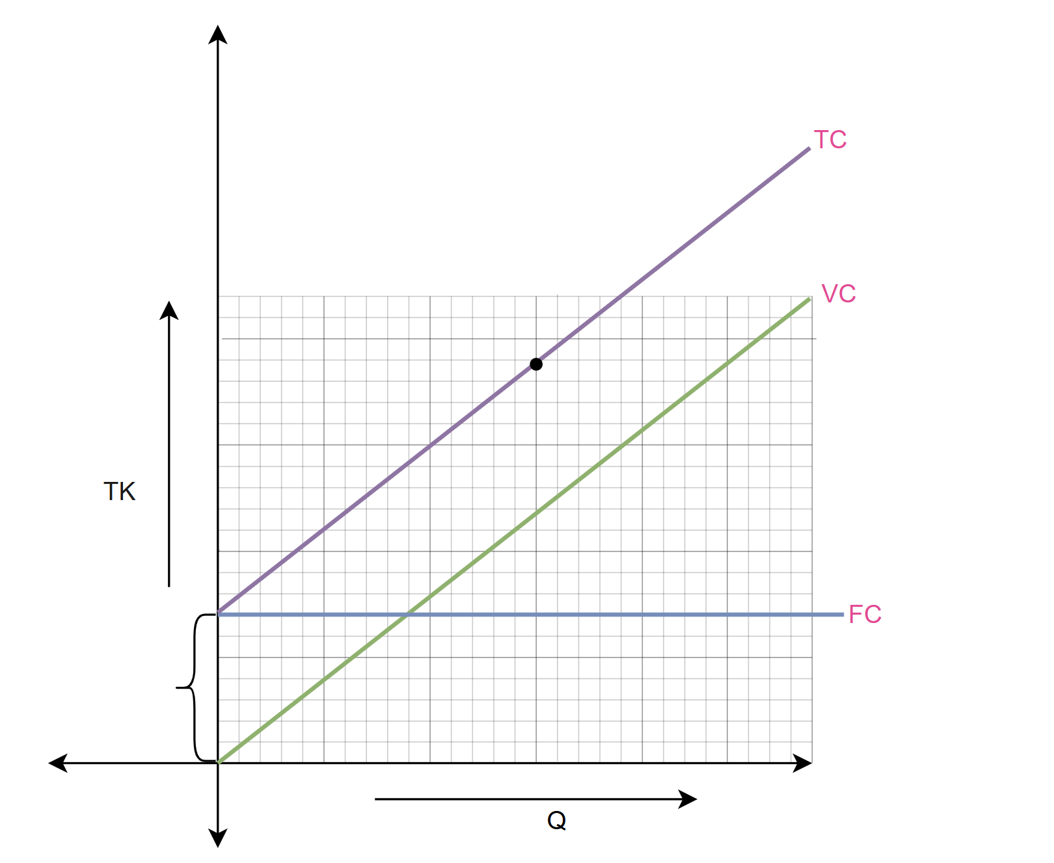

c) Total Cost (TC)
$$TC=FC+(VC×Q)$$

d) Total Revenue (TR)
$$TR=Price per unit×Q$$
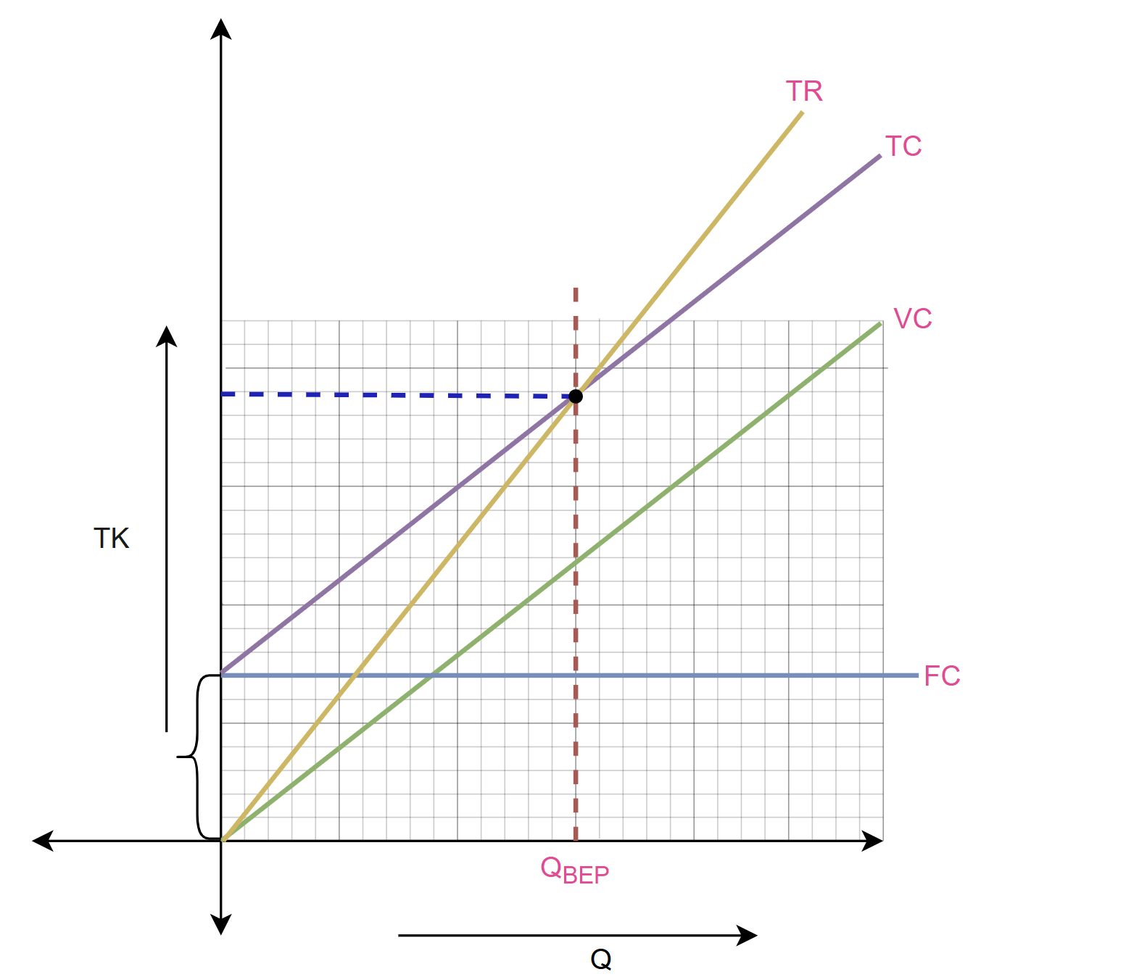

e) Profit
$$Profit=TR-TC$$

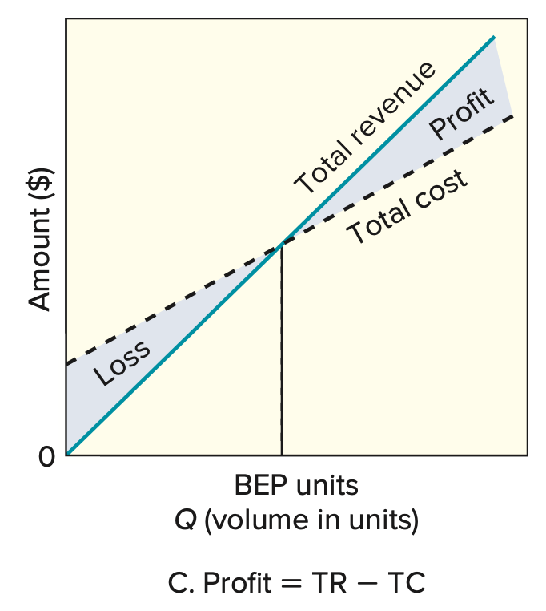
Break-Even Point (BEP)
- The output quantity where total revenue = total cost (no profit, no loss).
- Break-even quantity formula:
$$Q_{BEP}​=\frac{FC}{P-VC}$$
Where:
- P = price per unit
- VC = variable cost per unit
- FC = fixed cost
- Problem3: The owner of Old-Fashioned Berry Pies, S. Simon, is contemplating adding a new line of pies, which will require leasing new equipment for a monthly payment of $6,000. Variable costs would be $2 per pie, and pies would retail for $7 each.
- How many pies must be sold in order to break even?
- What would the profit (loss) be if 1,000 pies are made and sold in a month?
- How many pies must be sold to realize a profit of $4,000?
- If 2,000 can be sold, and a profit target is $5,000, what price should be charged per pie?
Solution:
Is given,
- FC = $6,000
- VC = $2
- P = $7
(a)
We know,
$$Q_{BEP}​=\frac{FC}{P-VC}=\frac{6000}{7-2}=1200 unit per month$$
∴ 1,200 pies must be sold to break even.

(b)
Is given,
- Q = 1000 Unit
We know,
$$Profit=TR-TC$$
$=P×Q-\left\{FC+(VC×Q)\right\}$
$=7×1000-\left\{6000+(2×1000)\right\}$
$=-\$1000$
∴ Loss = $1,000.

(c)
Is given,
- Profit = $4000
We know,
$$Profit=TR-TC$$
$=P×Q-\left\{FC+(VC×Q)\right\}$
$=\left(P×Q\right)-FC-(VC×Q)$
$\left(VC×Q\right)-\left(P×Q\right)=-FC-Profit$
$Q(VC-P)=-FC-Profit$
$$Q=\frac{-FC-Profit}{(VC-P)}$$
$$Q=\frac{-6000-4000}{(2-7)}=2000 unit$$
$$Required units(Q)=\frac{FC+Target profit​}{P-VC}$$

(d)
Is given,
- Profit = $5000
- Q = 2000
We know,
$$Required units\left(Q\right)=\frac{FC+Target profit​}{P-VC}$$
$$P=\frac{FC+Target profit​}{Q}+VC$$
$$P=\frac{6000+5000​}{2000}+2$$
$$P=\$7.5$$
∴The price should be $7.50 per pie.

Inhouse production or outsource
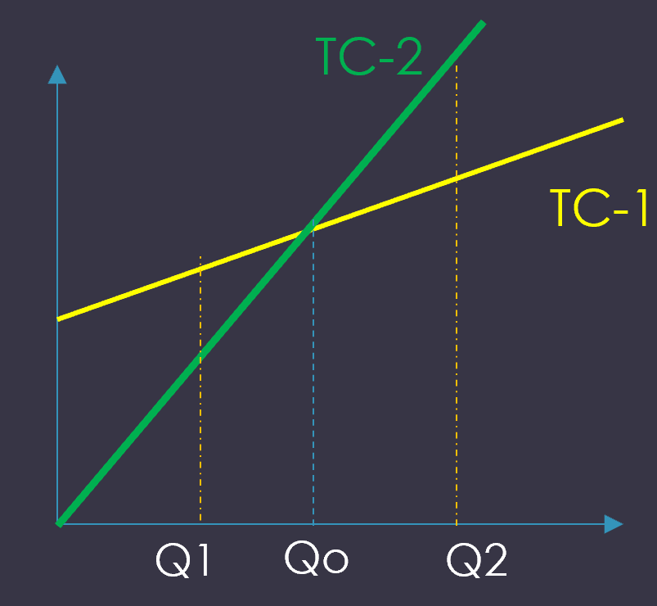
- $If Q<Q_{0} → Outsourcing is cheaper$
- $If Q>Q_{0} → In house production is cheaper$
- Problem4: A firm’s manager must decide whether to make or buy a certain item used in the production of vending machines. Making the item would involve annual lease costs of $150,000. Cost and volume estimates are as follows:

 | Make | Buy
Annual fixed cost | $150,000 | None
Variable cost/unit | $60 | $80
Annual volume (units) | 12,000 | 12,000
- Given these numbers, should the firm buy or make this item?
- There is a possibility that volume could change in the future. At what volume would the manager be indifferent between making and buying?
Solution:
Is given, for make:
for Buy:
- FC = 0
- VC = $80
- Q = 12,000

- FC = $150,000
- VC = $60
- Q = 12,000

(a)
We know,
For make:
${TC}_{Make}​=FC+\left(VC×Q\right)$
$${ TC}_{Make}​=150,000+\left(60×12,000\right)$$
$${ TC}_{Make}​=\$870,000$$
For Buy:
${TC}_{Buy}​=FC+\left(VC×Q\right)$
$${ TC}_{Buy}​=0+\left(80×12,000\right)$$
$${ TC}_{Buy}​=\$960,000$$
∴ Make is cheaper. The firm should make the item. (Savings = $960,000 − $870,000 = $90,000.)

(b)
We know,
Indifference volume:
${TC}_{Make}​={TC}_{Buy}​$
${FC}_{make}+{\left(VC×Q\right)}_{make}={FC}_{Buy}+{\left(VC×Q\right)}_{Buy}$
$$150,000+\left(60×Q\right)=\left(80×Q\right)$$
$150,000=80Q-60Q$
$20Q=150,000$
$Q=\frac{150,000}{20}$
$Q=7,500 unit$

∴Indifferent volume: 7,500 units (below this buy is cheaper; above this make is cheaper).

- Problem5: A small firm produces and sells automotive items in a five-state area. The firm expects to consolidate assembly of its battery chargers’ line at a single location. Currently, operations are in three widely scattered locations. The leading candidate for location will have a monthly fixed cost of $42,000 and variable costs of $3 per charger. Chargers sell for $7 each. Prepare a table that shows total profits, fixed costs, variable costs, and revenues for monthly volumes of 10,000, 12,000, and 15,000 units. What is the break-even point? Also determine the profit when volumes equal 22,000.
Solution:
Is given,
- FC = $42,000
- VC = $3
- P = $7
Volume ($Q_{i}$) | Revenue  $${TR}_{i} = P×Q_{i}$$ | Variable Cost  $$T_{VC_{i}} = VC×Q_{i}$$ | Fixed Cost | Total Cost  $${TC}_{i} = FC+T_{VC_{i}}$$ | Profit  $${=TR}_{i}-{TC}_{i}$$
10,000 | $70,000 | $30,000 | $42,000 | $72,000 | –$2,000
12,000 | $84,000 | $36,000 | $42,000 | $78,000 | $6,000
15,000 | $105,000 | $45,000 | $42,000 | $87,000 | $18,000

Break-even point,
$$Q_{BEP}​=\frac{FC}{P-VC}=\frac{42,000}{7-3}=10,500 unit per month$$
∴ $10,500$ unit must be sold to break even.
We know,
$$Profit=TR-TC$$
$=P×Q-\left\{FC+(VC×Q)\right\}$
$=7×22,000-\left\{42,000+(3×22,000)\right\}$
$=\$46,000$
∴ Profit = $\$46,000$

- Problem6: A small firm intends to increase the capacity of a bottleneck operation by adding a new machine. The annual fixed cost would be Tk. 42,000/-, variable cost per unit would be Tk. 15/- and revenue per unit would be Tk. 22/-.
- Write down the cost, revenue, and profit function.
- What annual volume is required to break even?
- What would be the profit if 5,000 units were made?
- How many units must be sold to realize a profit of Tk. 7,000/-?
- 1000 units can be sold, and profit target is Tk. 4,000/-, What price should be charged per unit?
- Solution:
Is given,
- FC = 42,000 tk
- VC = 15 tk
- P = 22 tk
(i)
Cost Function: | Revenue Function:
$$TC​=FC+\left(VC×Q\right)$$  $$TC​=42,000+\left(15×Q\right)$$  $$TC=42,000+15Q$$ | $$TR=Price per unit×Q$$  $$TR​=22×Q$$  $$TR=22Q$$
Profit Function:
$$Profit​=TR-TC$$
$$Profit​=22Q-\left(42,000+15Q\right)$$
$$Profit=7Q-42,000$$
(ii)
Break-even point,
$$Q_{BEP}​=\frac{FC}{P-VC}=\frac{42,000}{22-15}=6,000$$
∴ $6,000$ unit must be sold to break even.

(iii)
Is given,
- Q = 5000 Unit
We know,
$$Profit=TR-TC$$
$=P×Q-\left\{FC+(VC×Q)\right\}$
$=22×5000-\left\{42,000+(15×5000)\right\}$
$=-7000tk$
∴ Loss = 7,000tk.
(iv)
Is given,
- Profit = 7000tk
We know,
$$Required units(Q)=\frac{FC+Target profit​}{P-VC}$$
$$=\frac{42000+7000​}{22-15}$$
$$=7000 unit$$
(v)
Is given,
- Profit = 4000 tk
- Q = 1000 unit
We know,
$$Required units\left(Q\right)=\frac{FC+Target profit​}{P-VC}$$
$$P=\frac{FC+Target profit​}{Q}+VC$$
$$P=\frac{42,000+4000​}{1000}+15$$
$$P=61tk$$
∴The price should be 61tk per unit.
- Problem7: A producer of pottery is considering the addition of a new plant to absorb the backlog of demand that now exists. The primary location being considered will have fixed costs of $9,200 per month and variable costs of 70 cents per unit produced. Each item is sold to retailers at a price that averages 90 cents.
a. What volume per month is required in order to break even?
b. What profit would be realized on a monthly volume of 61,000 units? 87,000 units?
c. What volume is needed to obtain a profit of $16,000 per month?
Solution:
Is given,
- FC = $9,200
- VC = $0.70
- P = $0.90
(a)
We know,
$$Q_{BEP}​=\frac{FC}{P-VC}=\frac{9200}{0.90-0.70}=46,000 Units$$
∴ 46,000 units must be required per month.

(b)
Is given,
- Q = 61,000 Unit
We know,
$$Profit=TR-TC$$
$=P×Q-\left\{FC+(VC×Q)\right\}$
$=0.90×61,000-\left\{9200+(0.70×61,000)\right\}$
$=\$3000$
∴ Profit = $3,000.

Is given,
- Q = 87,000 Unit
We know,
$$Profit=TR-TC$$
$=P×Q-\left\{FC+(VC×Q)\right\}$
$=0.90×87,000-\left\{9200+(0.70×87,000)\right\}$
$=\$8200$
∴ Profit = $8,2000.

(c)
Is given,
- Profit = $16,000
We know,
$$Required units(Q)=\frac{FC+Target profit​}{P-VC}$$
$$=\frac{9200+16,000​}{0.90-0.70}$$
$$=126,000 unit$$

- Problem7: A producer of felt-tip pens has received a forecast of demand of 30,000 pens for the coming month from its marketing department. Fixed costs of $25,000 per month are allocated to the felt-tip operation, and variable costs are 37 cents per pen.
a. Find the break-even quantity if pens sell for $1 each.
b. At what price must pens be sold to obtain a monthly profit of $15,000, assuming that estimated demand materializes?
Solution:
Is given,
- FC = $25,000
- VC = $0.37
- P = $1
(a)
We know,
$$Q_{BEP}​=\frac{FC}{P-VC}=\frac{25,000}{1-0.37}≅39,683 Units$$
∴ 39,683 units must be required per month.
(b)
Is given,
- Profit = $15,000
- Q = 30,000 unit
We know,
$$Required units\left(Q\right)=\frac{FC+Target profit​}{P-VC}$$
$$P=\frac{FC+Target profit​}{Q}+VC$$
$$P=\frac{25,000+15,000​}{30000}+0.37$$
$$P=\$1.70$$
∴The price should be $1.70 per unit.
- Problem8: Haripur Power Plant procures electricity for distribution. The plant has a design capacity of 360 MW, an effective capacity of 340 MW, and an actual output of 330 MW.
a. Compute the efficiency of the power plant.
b. Compute the utilization of the power plant.
- Solution:
Utilization | Efficiency
$$Utilization=\left(\frac{Actual Output}{Design Capacity}\right)× 100\%$$  $$=\left(\frac{330MW}{360MW}\right)× 100\%$$  $$=91.667\%$$ | Efficiency $=\left(\frac{Actual Output}{Effective Capacity}\right)× 100\%$  $$=\left(\frac{330MW}{340MW}\right)× 100\%$$  $$=97.05\%$$
- Problem9: A company produces five different products with the following annual demand and processing time per unit:
Product | Annual Demand  (units) | Processing Time per Unit  (hours)
A | 400 | 3
B | 370 | 2
C | 430 | 8
D | 200 | 5
E | 600 | 10
The machine (equipment) has an annual capacity of 3500 hours.
- How many machines will be required to meet the annual demand for these five products?
- Solution:
(a)
Product | Annual Demand | Standard Processing  Time per Unit (hr) | $$Total Processing$$  $$time needed$$  TPR = AD $×PT$
1 | 400 | 3 | $$400×3=1200$$
2 | 370 | 2 | $$370×2=740$$
3 | 430 | 8 | $$430×8=3440$$
4 | 200 | 5 | $$200×5=1000$$
5 | 600 | 10 | $$600×10=6000$$
 | Total: |  | 1200+740+3440+1000+6000 = 12380

We know,
$$Required machine =\frac{Total Processing Time needed }{Processing time capacity per unit}$$
$$=\frac{12380 }{3500 hr/machine}=3.53$$
∴ Machines needed = 3.53
- Because we cannot buy 0.53 of a machine, you must round up: $\left\lceil 3.53\right\rceil =4$
∴ Machines needed = 4

- Problem10: A company produces juice and sells to the consumer market in Bangladesh. It produces three different types of juice: Mango, Orange, and Papaya. The company runs 8 hours per day and 240 days per year. Currently, the company has five machines that process the fruits and convert them into juice. Each machine can produce any type of juice. Due to a negative compliance issue of a competitor, the marketing department has forecasted a potential significant increase in sales.
The standard processing time and forecast for each type are given below:
Types | Mango | Orange | Papaya
Standard processing time | 3 min | 4 min | 3 min
Forecast for year 2024 (packs) | 140,000 | 120,000 | 80,000
a. Based on the information; identify how many extra machines the company needs to acquire for next year to fulfill the forecasted market demand.
b. At present, the overall efficiency on the shop floor is 80%. Considering this efficiency, what will be the total number of machines required to fulfill the forecasted market demand?
c. Currently, the company purchases the paper packages for the juice from a supplier. One of the executives suggested a business proposal of producing the packages in-house. It will require purchasing new equipment with an annual bank interest of 5,000 BDT per month and hiring staff with a fixed salary of 20,000 BDT per month. The material, energy, and operating cost will be 2 BDT per pack. Currently, the company pays 5 BDT per pack to the supplier. Based on the available information, should the company continue buying from the supplier next year or proceed with the executive’s proposal to produce the packages in-house?
- Solution:
(a)
Product | Annual Demand  (AD) | Standard Processing  Time per Unit (hr)  (PT) | $$Total Processing$$  $$time needed$$  TPR = AD $×PT$
Mango | 140,000 | 3/60 = 0.05 | $$140,000×0.05=7000$$
Orange | 120,000 | 4/60 | $$120,000×(\frac{4}{60})=8000$$
Papaya | 80,000 | 3/60 = 0.05 | $$80,000×0.05=4000$$
 | Total: |  | 7000+8040+4000 = 19000
Is given,
One machine works:
- 8 hours/day
- 240 days/year
We know,
$$annual processing time capacity=8×240$$
$=1920 hours per machine per year$
∴One machine provides 1,920 hours per year

$$Required Machine =\frac{Total Processing Time needed }{Processing time capacity per unit}$$
$$=\frac{19000 }{1920 hr/machine}=9.89 ≈10$$
∴ Machines needed = 10
(b)
Is given,
- $Annual processing time capacity=1,920$
- Efficiency $=80\%$
We know,
$$Required Machine =\frac{Total Processing Time needed }{Processing time capacity per unit×Efficiency}$$
$$=\frac{19040}{1920 ×80\%}=12.39 ≈13$$
$$Total machines needed= 13$$
$$So additional machines needed: 13-5=8$$

(c)
Is given, for Buy from supplier:
- $Q=140,000+120,000+80,000=340,000 unit$
- Cost per pack = 5 BDT
- FC = 0tk
We know,
$$TC​=FC+\left(VC×Q\right)$$
$TC​=0+\left(5×340,000\right)$
$TC​=0+\left(5×340,000\right)$
$TC​=1700000tk$

Now, for Produce in-house:
- $Q=140,000+120,000+80,000=340,000 unit$
- Cost per pack (VC) = 2 BDT
- FC = 20,000 $×12$ + 5000 $×12$ = 300000tk per year

We know,
$$TC​=FC+\left(VC×Q\right)$$
$TC​=300000+\left(2×340,000\right)$
$TC​=980000tk$

Compare Costs,
- Buy from supplier: 1,700,000 BDT
- Produce in-house: 980,000 BDT

$$Savings=1,700,000-980,000=720,000 BDT saved$$
∴ so in-house production is the better option.

- Problem11: A company located in Hong Kong wants to launch a new product. It must pay $20,000 per year as equipment rent. Each product has a direct material cost of $10 per unit and a labor cost of $20 per unit, both of which are variable costs. The selling price is set at $50 per unit.
a. How many units must be sold per month to avoid a loss?
b. How many units must be sold to generate $10,000 profit per year?
c. The marketing department estimates that only 8,000 units can be sold next year. To maintain a profit of $1,000 per month, what should be the selling price per unit?
d. A proposal suggests outsourcing production from a supplier in Bangladesh, who will charge $40 per unit (including product cost and shipping). For the estimated 8,000 units next year, which option will cost less: producing in-house or outsourcing?

Solution:
Is given,
- FC = $20,000 per year
- VC = $10 + $20 = $30 per year
- P = $50 per year
(a)
We know,
$$Q_{BEP}​=\frac{FC}{P-VC}=\frac{20,000}{50-30}=1000 units per year$$
∴Units per month:
$$Units per month​=\frac{1000}{12}=83.33≈84 unit per month$$
(b)
Is given,
- Profit = $10,000 profit per year
We know,
$$Required units(Q)=\frac{FC+Target profit​}{P-VC}$$
$$=\frac{20,000+10,000​}{50-30}$$
$$=1500 unit$$
(c)
Is given,
- Profit = $1000 $×12=\$12000 per year$
- Q = 8,000 unit
We know,
$$Required units\left(Q\right)=\frac{FC+Target profit​}{P-VC}$$
$$P=\frac{FC+Target profit​}{Q}+VC$$
$$P=\frac{20,000+12,000​}{8000}+30$$
$$P=\$34$$
∴The price should be $34 per unit.
(c)
Is given, for Buy from supplier:
- $Q=8,000 unit$
- VC = $40
- FC = $0
We know,
$$TC​=FC+\left(VC×Q\right)$$
$TC​=0+\left(40×8000\right)$
$TC​=0+\left(40×8,000\right)$
$TC​=\$320,000$

Now, for Produce in-house:
- $Q=8,000 unit$
- VC = $30
- FC = $20,000

We know,
$$TC​=FC+\left(VC×Q\right)$$
$TC​=20,000+\left(30×8,000\right)$
$TC​=\$260,000$

Compare Costs,
- Buy from supplier: $\$320,000$
- Produce in-house: $\$260,000$

$$Savings=320,000-260,000=\$60,000 saved$$
∴ so in-house production is the better option.

